CO-OP to CAREER PACKET
JOB SEARCH TIMELINE
Overview
Detailed Timeline
Call 215-895-2185 to schedule an appointment with Nicole Dalberto, Senior Coordinator for Graduating Students
FAQs
Why attend the Fall and Spring Career Fairs?
Top employers recruit for June openings during the career fairs.
Why use the Dragon Jobs System?
Employers post full-time positions daily to this system. This system can also be used to look for positions posted nationally at other universities. New positions are posted year-round and for all majors.
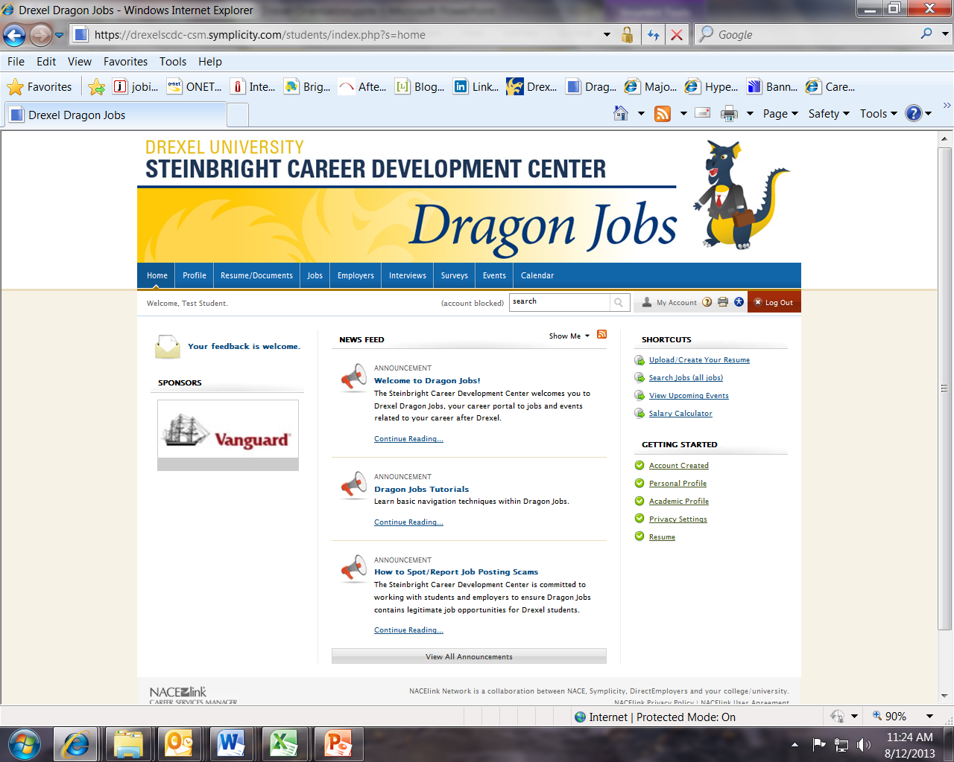
Check out announcements
Look under Jobs for NACElink with additional openings
Search for jobs and apply

What is On-Campus Recruiting?
On-campus recruiting is when employers come to campus, generally in the fall and winter, to conduct interviews for full-time positions targeting students graduating in June. You should create your Dragon Jobs profile and apply to positions within Dragon Jobs for these interviews.
Why Attend an Employer Information Session?
The best way to show your interest in employers is to attend an information session here on campus to learn more, ask questions and show that you would be the ideal candidate for the position. Employers are eager to talk with Drexel candidates.

TIPS FOR GRADUATING STUDENTS
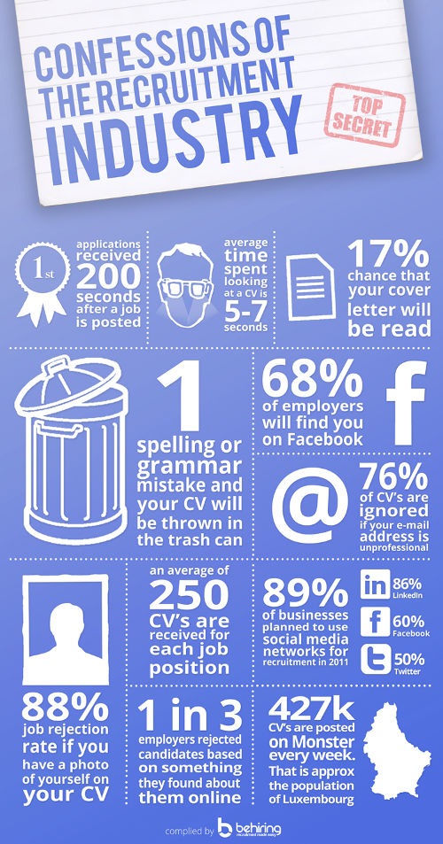
Source: Confessions the Recruiting Industry, Compiled by BeHiring
Management Skills  administered  analyzed  assigned  attained  chaired  consolidated  contracted  coordinated  delegated  developed  directed  enhanced  established  evaluated  improved  increased  initiated  instituted  managed  motivated  organized  oversaw  planned  prioritized  produced  recommended  reorganized  reviewed  scheduled  strengthened  supervised  UPGRADE YOUR RESUME  Analyze the job description, match the language, state accomplishments, elevate your action verbs, include percentages and quantities that impress. | Communication Skills  addressed  authored  collaborated  composed  contacted  convinced  corresponded  directed  drafted  edited  elicited  explained  formulated  influenced  interpreted  lectured  mediated  moderated  negotiated  persuaded  promoted  publicized  reconciled  recruited  resolved  spoke  translated  wrote | Research Skills  analyzed  clarified  collected  compared  conducted  critiqued  diagnosed  evaluated  examined  extracted  gathered  identified  interpreted  interviewed  investigated  located  organized  researched  reviewed  solved  summarized  surveyed  systematized  tested | Technical Skills  adapted  applied  assembled  built  calculated  computed  designed  developed  devised  engineered  fabricated  installed  maintained  operated  overhauled  programmed  remodeled  repaired  replaced  solved  standardized  studied  upgraded  utilized | Accomplishment  Skills  achieved  completed  expanded  improved  pioneered  reduced  resolved  restored  spearheaded  succeeded  surpassed  transformed  won
Teaching Skills  adapted/trained  advised/tutored  coached  communicated  coordinated  developed  enabled  encouraged  evaluated  explained  facilitated | Creative Skills  acted/planned  adapted/solved  composed/revitalized  conceptualized  created/shaped  customized  designed  developed  directed  established  fashioned | Helping Skills  advocated  aided  assessed  assisted  clarified  coached  counseled  demonstrated  diagnosed  educated  encouraged | Clerical or Detail Skills  approved  arranged  catalogued/recorded  charted/processed  classified/organized  coded/prepared  collected  compiled  dispatched  distributed | Remember to include numbers, percentages and industry key words.  Specific results will impress hiring managers, not a list of tasks.
HOW TO IMPRESS HIRING MANAGERS
Impress employers by quantifying what you’ve done. Think about specific achievements, accomplishments, and results from your work experience, student activities, and volunteer experience. Don’t be timid about your successes or exaggerate but try to remember the specifics.

Save money - Did you save the company money in any way? Notice or eliminate waste, or find a better way of doing things?
Make money (increase sales or revenue) - Did you make money for the company or organization? Increase sales by rearranging stock, producing marketing material, excelling at salesmanship? Increase revenue by organizing fund-raisers, writing successful proposals?
Save time - Did you save time for others by finding easier ways to do things, eliminating wasteful procedures?
Increase efficiency - Did you increase efficiency by organizing data better or developing systems to automate work?
Retain customers - Did you retain customers by providing superior customer service or resolve customer complaints?
Increase customer base - Did you increase the customer base by sales, improve reputation or increase visibility?
Train/Lead - Did you train other employees, assume or were granted leadership roles or roles of responsibility or delegate responsibility?
Improve quality of life - Did you teach skills that help day to day life, improve someone’s environment/lifestyle, brighten someone’s day or ease someone’s pain?
Teach teamwork/sportsmanship - Did you mentor/train children or adults in leadership or team building skills or inspire other to achieve?
Develop confidence/self-esteem in others – Did you improve someone’s self-esteem or confidence by teaching new skills or improving existing skills?
Lead/Motivate - Did you lead a team or group and motivate them to get something done in sports, arts, student groups, project teams, or work groups?
Examples:
- Developed efficient laboratory technique for isolating protein and reduced processing time by 20%
- Increased customer sales by 15% by identifying customer preferences and suggesting top trends in store
- Trained 10 employees on policies, protocols and company procedures to increase performance abilities of new staff quickly
COVER LETTER GUIDE
10 Cover Letter Mistakes to Avoid
1: Don’t Overuse “I”
2: Don’t Use a Weak Opening
3: Don’t Omit Your Top Selling Points
4: Don’t Make It Too Long
5: Don’t Repeat Your Resume Word for Word
6: Don’t Be Vague
7: Don’t Forget to Customize
8: Don’t End on a Passive Note
9: Don’t Be Rude
10: Don’t Forget to Sign it
Source: Kim Isaacs, Career Expert
Your Name
Street Address
City, State Zip Code
Date
Individual's Name
Job Title
Name of Organization
Street Address
City, State Zip Code
Dear Mr./Ms. ________________________________:
OPENING: Provide a basic personal intro. State the reason for writing. Name the specific position or type of work for which you're applying and where you found the opportunity. Include your availability. Persuasively emphasize skills, knowledge or abilities sought by the employer that you bring.
BODY: Explain why you're interested in working for this employer by focusing on their mission and your knowledge of them. Prove that you would be an excellent fit by describing where you gained the abilities and skills they seek in the job description and include specific results. Tell your story; don’t list the information from your resume. Remember, the reader will consider this an example of your writing skills. Explain why you want to work for them.
CLOSING: Mention that your resume is enclosed and indicate your desire to meet with the employer. Emphasize again the skills, knowledge and abilities sought by the employer that you can offer. Include phone and email. Finally, thank the employer for his/her time.
Sincerely,
(Your Signature)
Typed Name

COVER LETTER SAMPLE
Joe Smith
4871 Town Street
Philadelphia, PA 19104
October 4, 20XX
Ms. Michelle Duncan
Human Resources Department
Jetson Corporation
1304 Rothdale Drive, Suite 152
Jetson, NC 45123
Dear Ms. Duncan:
I am writing to inquire about the SCC position with Jetson Corporation that is currently being advertised on the company’s website. In June, 20xx, I will be graduating with a bachelor of science degree from Drexel University, with a major in XYZ engineering, and minors in WRP engineering and MPV engineering. I believe that my academic background and relevant work experience have given me the x, v, and r skills necessary to fill this position and add real value to your company.
My interest and commitment to XYZ engineering is long-standing, and my diverse experience makes me an excellent candidate for the SCC position. As a sophomore, I secured an environmental engineering research position in XYC. My research focused on bacterial biodegradation toward environmental contaminants in soil and polluted groundwater, and I presented my findings at the Drexel University College of Engineering Graduate Research Day. The Jetson Corporation focus on XYZ is impressive and aligns perfectly with my background in environmental research.
As a pre-junior, I accepted a Drexel University co-op position with BBB Associates. During my six month co-op, I gained valuable experience participating in several land development and roadway projects. In my junior year, I accepted a co-op position with CCC in their Philadelphia, PA office. During this six month co-op, I gained valuable exposure to the water and wastewater industry. As a senior student, I am currently working on my College of Engineering Senior Design Project. Our goal is to design an AAA complex for LLL Township. This Senior Design Project will give me invaluable experience in working with a team for a real-world client.
I believe that my diverse industry background, from my research experience, my varied co-op positions, and my real world client interactions, makes me well-suited for the position. Please review my attached resume, which provides full details of my qualifications. Please feel free to contact me at phone number#### or email@. Thank you for reviewing my credentials. I look forward to speaking with you further about this SCC Engineer position at Jetson Corporation.
Sincerely,
(Signature)
Joe Smith

LINKEDIN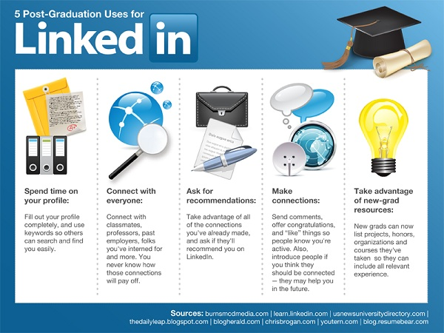
1. Use your inbox
Contrary to popular belief, networking doesn’t mean reaching out to strangers. The best networks begin with those you know and trust, and then grow based on personal referrals. Start building your LinkedIn network by uploading your online address book and connecting to friends, relatives, co-op colleagues, and professionals you know in the “real world.”
2. Get personal
As you build your connections on LinkedIn, always customize your connection requests with a friendly note and, if necessary, a reminder of where you met or what organization you have in common. If you’re being referred by a mutual friend, write a brief intro of who you are and why you’d like to connect. You’ll impress people with your personal touch.
3. Join the “In” crowd
Another way to form new online relationships is to join LinkedIn Groups. Start with DREXEL CAREER CONNECTIONS. Also, alums love to connect with students—and then find volunteer organizations or professional associations you already belong to. As a member, you can comment on discussions, find exclusive job listings, and meet people who share common interests.
SALARY NEGOTIATION
Remember to review salary.com, glassdoor.com, and NACE.com salary information first to gather salary data for different levels of experience and different locations where cost of living is different. Look at the entire offer package including salary, signing bonus, retirement package and matching funds, and benefits. The company may have a range listed on their website for your position.

Eight Etiquette Tips for Salary Negotiation
1. Wait for the employer to make an offer. See if you can push or delay the salary discussion until after you've secured the position and proven yourself valuable to the company, says Liz Taylor, founder of the consulting company Etiquette Principles. "Think about it this way, if the employer wants you to work at their company then you are in a much better position of power to negotiate," she says.
2. Don't mention personal reasons why you need money. This reeks of desperation—not to mention the fact that discussing your personal issues is very unprofessional.
3. Be flexible. One way to achieve flexibility is to offer a range rather than a firm number. "If a company can't meet you at the magical number, be open to alternatives such as profit sharing, strong benefit platform, stock options, company car with expense allowance, etc. Some of these perks really add up quickly," Taylor says.
4. Give the employer hard evidence as a reference. Respect your employer's time by coming prepared with research and a hard copy of your salary request. This way, s/he won't have to take notes himself. Your research should include your market value (which you can research using salary calculators) as well as your (past or potential) quantifiable contribution to the company. Talk to other folks in your field about average ranges just to confirm your asking salary range is realistic. "Knowing industry averages and market demand are crucial in your negotiations." Your goal should be to get at least the market rate based on your experience and your position.
5. Never interrupt, ever. Egan stresses this point—it might be tempting to interrupt in the heat of the moment but talking over your boss won't do you any favors.
6. Give them time to think about it. They might have to consult their managers or do some more research themselves. Let them know that they don't have to respond to your counteroffer right away.
7. If you get shot down, don't show disappointment. Take it in stride, Egan says. "Follow it up with 'what can I do differently or more of to assure that I will receive the increase I seek next year?'" she says. "Take notes on all this, give your boss quarterly progress reports and do each one 110 percent."
8. End the conversation on a light, friendly note. Thank them for their time and ask about how they're doing in general. Small talk can go a long way after an intense conversation.
Source: http://money.usnews.com/money/blogs/outside-voices-careers/2012/06/05/8-etiquette-tips-for-salary-negotiation
RECOMMENDATIONS FOR GRADUATING STUDENTS
1. Edit your profile. Recruiters do extensive web searches on people they intend to hire, including checking social media sites like Facebook and Twitter.
2. Do your homework. Don't just figure that you can post a resume on monster.com and find work, says Janice Bryant Howroyd, CEO of staffing company AppleOne. Study all aspects of your chosen field and seek information about the companies doing business in your industry.
3. Prepare to relocate. Live in a city where the job prospects are bleak? You can vastly increase your chance of getting work by seeking employment in other zip codes.
4. Think small. Many graduates focus on big, brand-name companies, but it's the smaller and mid-sized companies that are doing most of the hiring now, Howroyd says.
5. Set targets. Set goals every day for either contacting a certain number of people in your community; sending out a set number of resumes; filling out a set number of applications; or finding a set number of new opportunities.
6. Be persistent. If you go to an interview and don't hear from the employer, follow up with a phone call. If they gave the job to another person, don't be angry - be interested. Politely ask the hiring manager if he or she can tell you whether there was something that the other person did that particularly impressed them or something that you could improve.
7. Work your network. Ask your friends, your parents, your parents' friends, if they know of anything that would suit you. Check in with your college career office and attend alumni functions. When there are hundreds of people applying for a given job, a personal referral can make your application stand out.
8. Be a temp. Some companies may not be willing to hire permanent full-time staff, but need help. You can sign up with a temporary company that will send you out on a daily basis to these companies. The benefits: you earn money; you get to know employers; and employers get to know you.
9. Don't despair. It's a tough job market, so it could take time to get work. And when you do get work, it may not be the “perfect job” that you envisioned. Keep a good attitude and it may be a helpful stepping stone.

